OudhTrade
Frontend Technical Design
Module 1 — Platform Foundation · M01-4
Document details
Company | MRIDA INFRA AND PLANTATIONS LLP
Product | OudhTrade — oudhtrade.com
Document | M01-4 Frontend Technical Design
Module | M01 Platform Foundation (release R1)
Readers | Frontend and mobile developers, UX, tech lead
Related documents | PRD (PRD-FND, PRD-CMP) · HLD · other M01 documents
Owner | Tech lead
Decision owner | T. Satish Reddy, CEO & Founder
Status | Draft for review — 24 September 2026
Classification | Confidential — for partners and the OudhTrade team

Contents
1. Overview 2
1.1 White-label 3
2. Rendering, Routing and SEO 3
3. Languages, Right-to-Left and Formatting 3
4. Upload Components 3
4.1 Farmer simple mode for uploads 4
5. Price and Unit Display 4
6. Cookie Banner 5
7. Error, Empty and Status Pages 5
8. Browser Security and Limits 5
9. Accessibility and Browser Support 6
9.1 Field-agent screens: installable web app with offline storage 6
10. Staff and Settings Screens 6
10.1 Shared settings-pattern components 7
10.2 Staff screen components 8

1. Overview
Module 1 provides the shared frontend foundation: the page shell, routing and addresses, language and formatting utilities, the upload components, the cookie banner, error pages and shared UI rules. The framework follows the team’s approved proposal (HLD 13.2): server-side rendering for public pages, responsive desktop-first layout, and the same API for web and apps.
Building block | Purpose
App shell | Header, footer, navigation, language / number-style / guide-currency switch, cookie-settings link, page containers; brand from design tokens and configuration
Router | Address patterns from M01-2 Section 6, redirects, “do not index” rules
i18n layer | Translation keys, fallback to English, right-to-left switch, formatting helpers
Upload components | PhotoUploader, DocumentUploader, VideoUploader
PriceDisplay | Metric price, traditional-unit helper line and guide price in the viewer’s chosen guide currency
API client | Shared request layer: sends an Idempotency-Key on create actions, reads RateLimit headers, follows cursors
PhoneInput & AddressForm | Country-aware phone number and address fields from the Country table
CookieBanner & CookieSettings | Consent capture and change
Error & status pages | 404, 500, maintenance, offline
ActivityList | “My account activity” (own audit subset)
Field-agent app support | Installable web app with offline storage for the field-agent screens (Section 9.1)
Staff and settings screens | Module 1 settings screens and the audit log viewer in the Admin app, and the shared settings-pattern parts every module reuses (Section 10)

1.1 White-label
No brand name, colours or logos are hard-coded (M01-2 ENV-012). Colours, fonts and spacing come from the design tokens (UX/UI Foundation, Section 6); the brand name, logo files, domain, email sender and legal entity come from configuration. Components never contain the text “OudhTrade”; it is a translation parameter filled from configuration.

2. Rendering, Routing and SEO
- Public pages (home, category, listing, storefront, guides) are server-side rendered for speed on 4G and for search engines; dashboards may render in the browser.
- Routes follow the address patterns; listing pages resolve by listing number and redirect (301) to the current title slug.
- Every public page sets title, description, canonical link, share-preview tags (WhatsApp, Facebook, LinkedIn) and structured product data; Opportunity, private and test pages add “noindex”.
- Performance budget: main pages usable ≤ 2.5 s on 4G; images lazy-loaded with responsive sizes; video loads only when played; JavaScript split per page.

3. Languages, Right-to-Left and Formatting
- All visible text uses translation keys; no hard-coded strings. Missing keys fall back to English and are reported in development.
- Layout uses logical CSS properties (start / end, not left / right) so switching to Arabic mirrors the layout; icons that show direction are mirrored.
- Shared helpers (same rules as the backend LocaleService): `formatNumber`, `formatMoney` (₹ / $, Indian or international grouping), `formatAmountWords` (lakh / crore or K / M), `formatDate` (24 Sep 2026), `formatTime` (user time zone).
- Number style comes from the user’s preference (Indian for India-based accounts by default); visitors get it from their browser country, changeable in the footer.
- Guide currency: Account → Preferences offers a guide-currency picker (currencies from the Country table, plus “Don’t show”), saved with `PUT /v1/me/preferences`. Visitors change it in the footer; the choice is kept with language and number style in the essential first-party setting `ot_prefs` (no identifier, no tracking — M01-3 Section 4) and copied to the account at sign-up or sign-in. PriceDisplay re-renders the guide line at once.
- Web fonts cover Latin, Arabic, Devanagari, Bengali-Assamese and Chinese / Japanese scripts; script fonts load only for the language in use.
- PhoneInput: country picker (flag and code) defaulting to the viewer’s country, formats as the user types, stores +country-code format. AddressForm: fields and order from the country’s address layout; names accept any script.

4. Upload Components
Component | Behaviour
PhotoUploader | Drag-and-drop or camera / gallery on mobile; multiple select; client-side type and size check (JPG, PNG, WEBP, HEIC; ≤ 15 MB); client-side downscale before upload where supported; progress bar per photo; reorder by drag; first photo marked “Cover”; count shown “3 of 10”; quality warning badge; “Held for review” state when a photo contains contact details or a QR code; one-line notice that location is never shown publicly; retry on failure.
DocumentUploader | PDF, JPG, PNG, HEIC / HEIF, WEBP ≤ 10 MB; shows file name and status (scanning → ready); never shows a public preview; “View” opens via signed link.
VideoUploader | MP4 / MOV ≤ 100 MB; reads duration in the browser and blocks > 60 s before upload; shows remaining video allowance (“1 of 2 used”); resumable upload with progress; status chip: Processing · In review · Live · Rejected (with reason); player muted by default with sound button.
Common | Upload goes straight to storage using the pre-signed POST link (storage refuses files above the purpose’s size limit); the component polls or listens for status; all messages translated; keyboard and screen-reader accessible.

4.1 Farmer simple mode for uploads
Farmer accounts, and field agents working for a farmer, get the simple version of the upload components (UX/UI Foundation, Section 8.7; M01-6 Section 3.1).
- Touch targets at least 48 × 48 px; larger text and one big primary button per step.
- Fewer steps: “Take photo” opens the camera directly; no drag-to-reorder (the first photo is the cover; “Make cover” button instead); watermark and other options hidden with safe defaults.
- Built for slow 3G: photos are downscaled on the phone before upload (long side 1,600 px); each file uploads separately with a large progress bar; after a network drop the upload resumes by itself (multipart upload for video, automatic retry for photos) and the queue is kept in the browser so it continues after the page is reopened.
- Clear states with icons and short words: “Sending…”, “Waiting for network — we’ll continue”, “Sent”, “Try again”.

5. Price and Unit Display
- Unit picker lists only the metric and count units allowed for the item (from the API); bigha, katha and lessa show a required state selector (only states with a factor, UNT-009).
- Price helper in the listing form: “Know your price per tola? Type it here” — fills the metric price field; only the metric price is saved.
- Display: main line “₹500 per ml”; helper line in smaller grey text “≈ ₹6,000 per tola”; guide line “≈ AED 22 per ml (guide only)” for viewers outside the listing currency. Helper units follow the category and viewer country.
- Area: “2 bigha (Assam) · ≈ 0.66 acre”. Count units show no conversion.
- Sort and filter by price per standard unit only within the same currency.

6. Cookie Banner
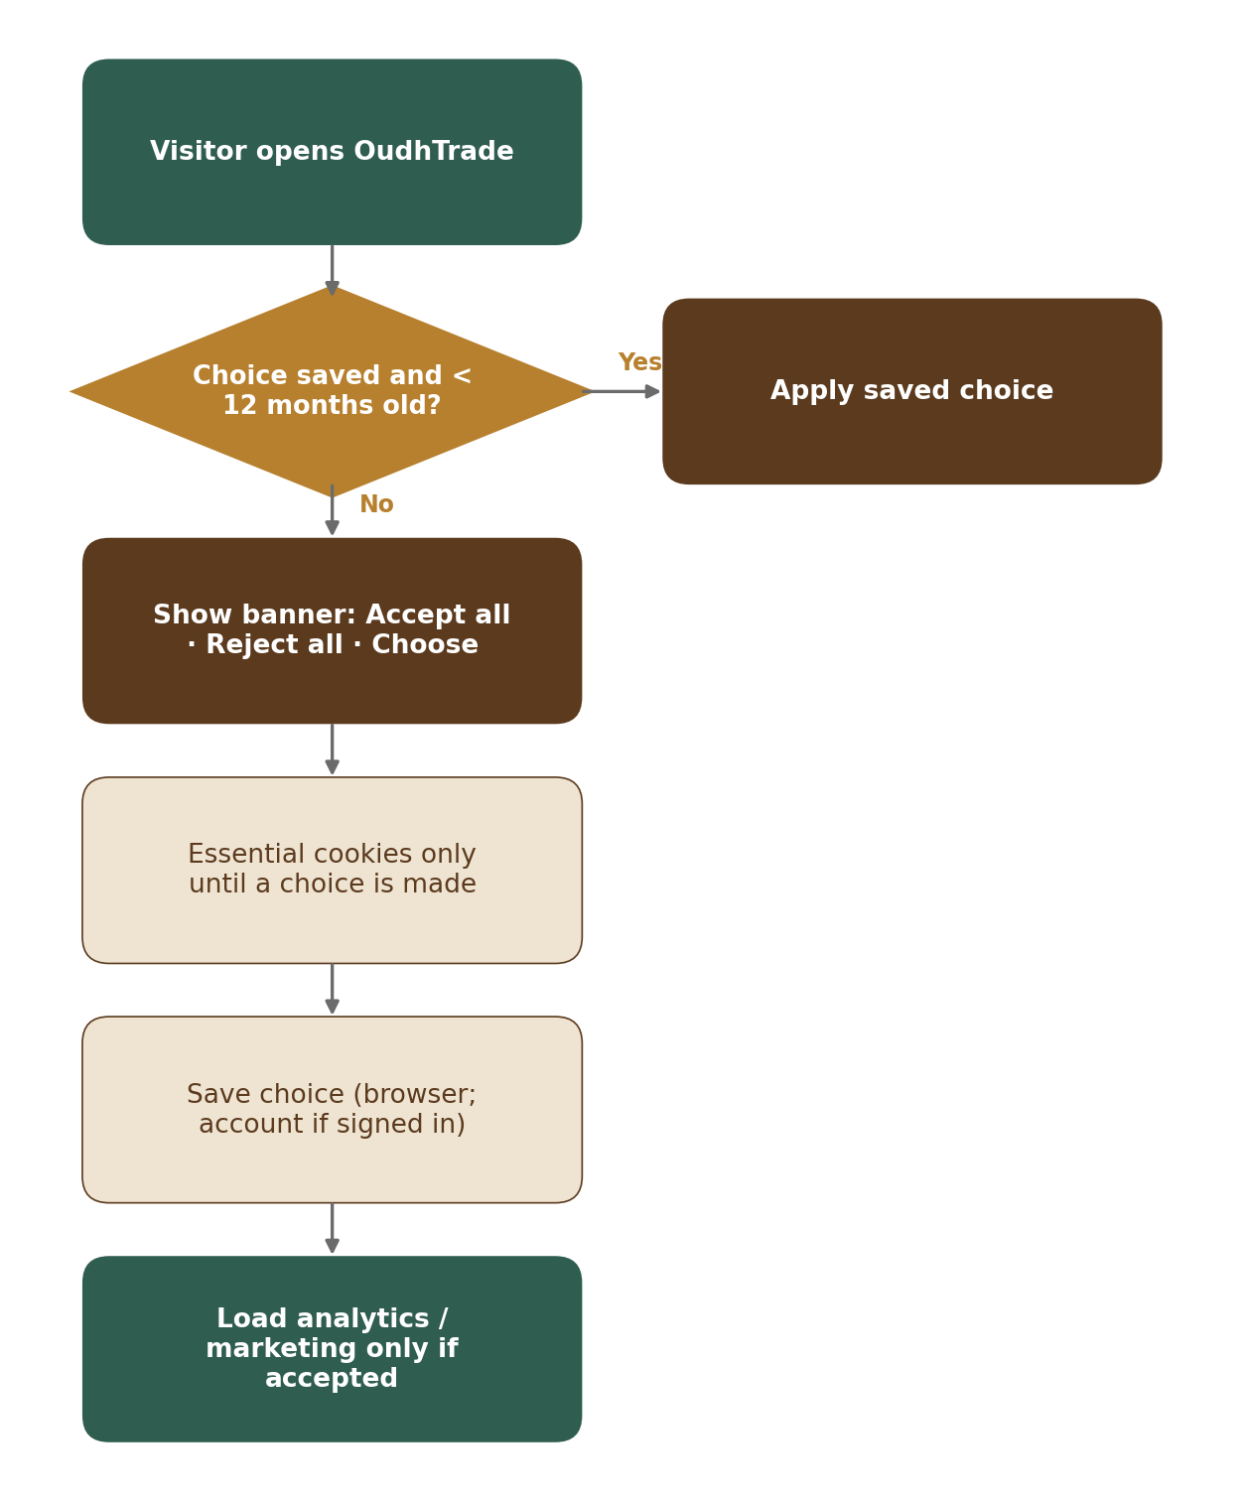
Figure 1 — Cookie consent flow
- Shown at the bottom on first visit; three equal buttons: Accept all · Reject all · Choose. “Choose” opens toggles for Analytics and Marketing (Essential shown as always on).
- No analytics or marketing script is loaded before consent; a tag manager is configured to respect the stored choice.
- Choice stored in a first-party cookie for 12 months and sent to `POST /v1/consents`; for signed-in users it is also saved to the account.
- Footer link “Cookie settings” reopens the choices; banner is accessible (focus trap, keyboard, screen reader labels).

7. Error, Empty and Status Pages
Page | Content
404 Not found | “We couldn’t find that page.” Search box, links to categories and help.
500 Something went wrong | Apology, “Try again”, request ID for support, help link.
Maintenance | Planned time window in the user’s time zone; link to status updates.
Offline (apps and web) | “You’re offline — we’ll retry when you’re back online”; uploads resume automatically.

8. Browser Security and Limits
- No inline scripts or styles, so the strict content security policy works; third-party scripts load only after cookie consent.
- Seller contact details are never placed in page HTML; they are fetched only when the owning module allows it.
- Forms send the CSRF token; the app handles “too many requests” by showing the translated wait message and retrying after the `Retry-After` time.
- Idempotency key: the client creates one UUID per create action (e.g. create upload slot, post listing, send enquiry, pay) and sends it as the `Idempotency-Key` header; the same key is reused when the request is retried after a time-out or network drop, so the action is never done twice (M01-3 Section 4.1). A new key is made only when the user starts a new action.
- Error pages and the maintenance page link to status.oudhtrade.com.

9. Accessibility and Browser Support
- WCAG 2.2 AA, following the UX/UI Foundation checklist (Section 11): colour contrast, focus states never hidden behind sticky bars or banners, keyboard use, button alternatives to dragging, labels for inputs, alt text for images (seller-provided or generated from title).
- Supported: latest two versions of Chrome, Safari, Edge, Firefox; Android 10+ and iOS 15+ browsers; responsive from 360 px wide.
- Touch targets at least 44 × 44 px, 48 × 48 px in farmer simple mode.
- Mobile apps (R3) reuse the same API, translation keys, formatting rules and upload rules.

9.1 Field-agent screens: installable web app with offline storage
Field agents often work in villages with no signal. Their screens are an installable web app on the managed agent phone. Module 1 provides the shared parts; M02 (queued farmer sign-up) and M03 (farmer profiles, farm-visit photos and reports) build their offline forms on them.
Part | Design
Install | Web app manifest and a service worker, so the agent can add the screens to the home screen and open them without signal. The agent signs in (staff realm) while online first.
Service worker | Caches only the app shell, scripts, styles, icons and translations for offline use. It never caches API responses that hold personal data. New versions install in the background and apply at the next start.
Encrypted local queue | Offline form entries are kept in the browser storage (IndexedDB) as a queue, encrypted with a key the web server gives only to that agent’s signed-in session. No password or one-time code is ever stored. The queue is wiped after 7 days (configurable), on sign-out, when another agent signs in on the device, or once sent.
Sending | When there is signal, queued items are sent with their idempotency key (M01-3 Section 4.1), so a retry never creates a record twice; photos use the normal upload with resume. The screen shows “Waiting for signal” and the wipe date for each queued item.

10. Staff and Settings Screens
The screens are specified in M01-6 Section 12. They live in the Admin app (HLD: separate deployment, staff sign-in realm): settings screens (under /admin/settings/…) inside the Configuration Console shell (M16); staff screens (under /admin/…) in the Operations Console layout (M15). The shells give navigation, staff sign-in and role checks; Module 1 builds the pages below and the shared settings-pattern parts. When they are built is decided by the team.
Route | Screen (M01-6) | Roles that can open it
/admin/settings/changes | Changes: waiting for my approval, my drafts, scheduled, recent (12.1) | Super Admin, Admin; Finance (My drafts tab only)
/admin/settings | Settings editor (12.2) | All staff roles except field agents; edit: Super Admin, Admin
/admin/settings/switches | Feature switches and overrides (12.3) | All staff roles except field agents; edit: Super Admin, Admin
/admin/settings/countries · /admin/settings/countries/{code} | Country table and country detail (12.4) | All staff roles except field agents; edit: Super Admin, Admin
/admin/settings/reserved-names | Reserved names (12.5) | Super Admin, Admin, Moderator (view)
/admin/settings/holidays | Holiday calendar (12.6) | All staff roles except field agents; edit: Super Admin, Admin
/admin/settings/rate-limits | Rate limits (12.7) | Super Admin, Admin
/admin/settings/ai-usage | AI usage and budgets (12.8) | Super Admin, Admin, Finance (view and draft)
/admin/audit · /admin/audit/{id} | Audit log viewer and record detail (12.9) | Super Admin, Admin, Moderator, Finance, Support, field agents (own actions) — scope from AUD-005
/admin/legal-holds · /admin/legal-holds/{id} | Legal hold: list, detail, place and release (12.10) | Super Admin, Admin; Moderator (view, items under review)
/admin/jobs/failed | Failed jobs: retrying and dead-letter tabs (12.11) | Super Admin, Admin
/admin/settings/retention | Retention policies (12.12) | Super Admin, Admin; Moderator, Finance (view)
/admin/settings/units · /admin/settings/units/land | Units and conversion factors; state land units (12.13) | All staff roles except field agents; edit: Super Admin, Admin
No route of its own (panel) | Photo location view (12.14), opened from the M03 verification review (screen A) and the M06 origin-check screens | Staff with the verification permission (M03)

The router checks the role on the server before the page is sent; a role without access gets the “Not allowed” state (M01-6 Section 12.1), never an empty page. Every item screen also has a History tab (`?tab=history`) and opens a draft at `…/draft/{versionId}`.

10.1 Shared settings-pattern components
Every module’s settings screens (e.g. the M03 editors) are built from these parts, so they all behave as in M01-6 Section 12.1.
Component | Behaviour
SettingsTable | List with search, filters, cursor paging, current value, “Waiting for approval” / “Scheduled” chips and “High impact” tag.
DraftEditor | Form built from the setting’s type and allowed range; checks each field as the user types; saves the draft with its row_version.
OverridePanel | Adds and removes overrides by account list, role, plan, category or country; lists them most specific first (CFG-005).
ImpactPreview | Calls the preview API (M01-3 Section 4) and shows what changes, who is affected and the example (CFG-008); refreshes for the approver.
ApprovalBar | Send for approval with a required reason; Approve / Reject with reason. Hides Approve from the editor of any draft, and from an Admin who is not a Super Admin on a high-impact draft (two-level rule, M01-6 Section 12.1). The server checks the same rule.
PublishScheduler | Publish now or at a date and time (shown in IST and the user’s zone); cancel a scheduled change with a reason (CFG-009).
VersionHistory & CompareView | Versions with status, people, time and reason; side-by-side old and new values; Roll back button that opens a new draft.
ConflictBanner | Shown on a 409 conflict: “Changed by someone else — please reload”, with the user’s unsaved values kept beside the new ones (CFG-007).
ImportExportDialog | Export a published version (staging); import a file as a draft (production), then the normal approval (ENV-008).
AuditSearch & AuditRecordView | Role-scoped search form and results with cursor paging; record detail with before / after and chain-check result; Export (Super Admin only) with a required reason (AUD-005 to AUD-008).

10.2 Staff screen components
Parts for the Module 1 staff screens in the Operations Console layout and for the photo location panel used by M03 and M06.
Component | Behaviour
LegalHoldList & LegalHoldForm | Active and released tabs with filters; place-hold form (scope, ID, reason, reference) with a coverage preview; release dialog showing what the next retention run would delete, with a required reason (RET-004).
FailedJobsTable | Retrying and dead-letter tabs; per-kind counts; Retry, Retry all of this kind (up to 100, reason required) and Discard (reason required) (EVT-005).
RetentionPolicyTable | Built from SettingsTable and DraftEditor; shows legal minimum and hold counts; refuses a period below the legal minimum before sending (RET-005).
UnitTable & LandUnitTable | Built from SettingsTable and DraftEditor; shows usage counts; state land units in sq ft and m² with a required source field (UNT-009).
PhotoLocationPanel | Button Show photo location → reason dialog (reason list and required note) → map, coordinates and distance from the declared district. No copy, download or export action. Rendered only for staff with the verification permission; the server checks again and records each view (FIL-027).

